Consumer Health Data Aggregator using Semantic Interoperability

Ioana Singureanu, Eversolve, LLC, Windham, New Hampshire, USA

**Abstract**

This paper describes the use of standards to enhance the capability of creating semantically interoperable documents and messages to support a patient-facing view of all the patient data stored across the continuum of care. Over the past few years, many information exchange formats have been created and many have already been adopted by Certified Health IT products [8]. While the health industry continues to develop new formats that attempt to simplify or modernize interoperability across healthcare, it is continually challenged by the difficulty of current applications to exchange documents that can be interpreted by the receiver of the document, message, or a granular resource/object. Given the variety of standard formats, a framework should be developed that can bridge across multiple exchanged formats/syntax and semantics. It should reference the business content in a consistent way that represents clinical best practices and connects to the clinical workflow that triggers information exchange. This paper describes the use of model-driven development to bring balance to the art of data exchange by supporting semantic interoperability for design and runtime to aggregated correctly and effectively heterogeneous data source into a comprehensive health data aggregate database. The proposed model-based and template-based approach to mapping addresses the semantic challenges and allows sending systems to first specify the meaning of their data by relating it to a defined common data dictionary of business data elements thus making it independent of other datasets. The resulting architecture proposes two sets of open-source components intended to provide a clear separation of concerns throughout the development process between design (“workbench”[4]) and run-time (“hub”[3]) to aggregate both behavioral health and physical health interoperability for health information exchange network (HIEs) and other aggregate clinical databases.

**Keywords**

Semantic Interoperability, Electronic Health Records, Clinical Document Architecture, Consolidated CDA, Fast Healthcare Interoperability Resources, Semantic Mapping, HL7 Version 2, Content-Assembly Mechanism, Model-Driven Health Tools, Information Exchange Hub, IExHub, CDA, C-CDA, CAM, FHIR, MDI, MDR

**Contents**

1. Background 3

Aggregating EHR Source Data 3

2. Problems in Aggregating Health Information 7

Why Mapping Standards Structure to Aggregate Clinical Data Fails 8

3. Semantic Consistency across the Continuum of Care 9

4. Benefits of Runtime Model-Driven Interoperability 9

5. Semantic Mapping Design 10

6. MDI Runtime Transformations 12

Transforming Atomic and Aggregate Data 13

7. Conclusions 18

References 19

# Background

Health information such as narrative descriptions are often exchanged between providers using a generic electronic format such as PDF and HTML. This is only marginally better than FAX and heavily reliant on human interpretation of the information received with little to no computer-aided processing or analysis. A human must refer to and interpret the electronic document anytime the information can be used in the treatment of a patient. As information exchange relies on both the sending and receiving clinicians to interpret it in the same way, the semantic modifiers such as “resolved,” “major,” “critical,” or “severe” that are associated with clinical information may be contextual. Thus, better interoperability requires semantic clarity that goes beyond human decoding of narrative information and requires machine processing of free-text and structured data. Similarly, it is important to convey such information as: “the patient does not report any allergies,” “we have no information about allergies,” or “tests reveal no allergies.”

Over the past decades, many information exchange formats have been created to exchange messages and documents. While the intent of these formats and approaches is to simplify interoperability, it has presented a very complex interoperability landscape for implementers to navigate. As a Standards Development Organization (SDO), Health Level Seven International (HL7) has developed several file formats for exchanging information. These include HL7 Version 2.x, HL7 Version 3, Clinical Document Architecture Release 2 (CDA R2), and Fast Healthcare Interoperability Resources (FHIR)[1]. All have been attempts to create machine-understandable structures with flexible semantic content, subject to implementation-specific clarifications. For standards to augment and improve interoperability, they must be associated with specific use cases. All HL7 standards have to be constrained (or extended) and combined with clinical terminology to create an implementable guide that attempts to eliminate ambiguity.

There are other content standards defined in the United States, such as the National Information Exchange Model (NIEM) and The Accredited Standards Committee X12 known as ASC X12 or simply X12. Layered below the content standards referenced above, there are transport protocols such as SOAP, REST, NwHIN DIRECT, and NwHIN CONNECT which are often tied to a particular information exchange standard and ignore semantic clarity.

Figure 1 illustrates the complexity faced by EHR systems expected to convey business information using Meaningful Use standards such as Consolidated Clinical Document Architecture (C-CDA) based on CDA R2, HL7 V2 Laboratory Results Interface (LRI) and Laboratory Orders Interface (LOI), HL7 Quality Reporting Document Architecture (QRDA), or Healthcare Quality Measure Format (HQMF), or emerging standards such as FHIR including the US-specific Data Access Framework (DAF) Implementation Guide. While other standards are well-suited for transaction, message, and document exchange, FHIR adds a simple set of REST-based interfaces suitable for querying repositories that store aggregate data sets.

## Aggregating EHR Source Data

Current FHIR adoption is its early stages and early adopters have been affected negatively by significant changes between FHIR versions and there is no backwards-compatibility between DSTU1 and DSTU2 and the same will be true until FHIR reach its “Normative” status. In HL7, DSTU approval requires only 60% affirmative votes while “Normative” standards require 90% approval. Ideally all Draft Standards for Trial use (aka “Standards for Trial Use”) are expected to undergo changes and a final “Normative” approval. Vendors are reluctant to implement standards that are still in a state of flux. Therefore many implementations are still relying on previously adopted Meaningful Use ( to aggregate clinical information and then make it available to applications as FHIR resources.

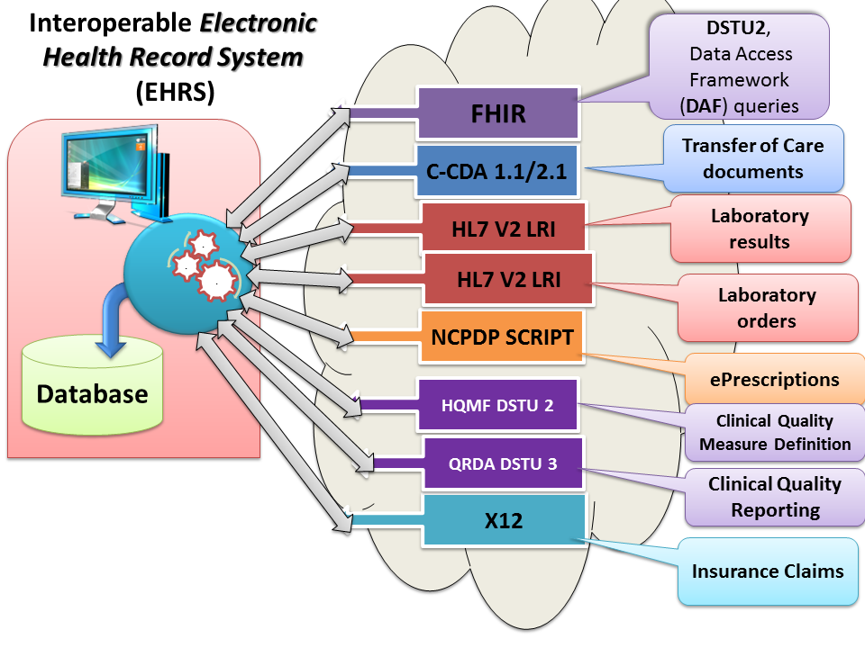

**Figure 1: Standard-based Specifications used to aggregate health information**

Therefore an EHR system certified from CHPL [8] can be a source of health information for Consumer Health Data Aggregator (CHDA). The proposed approach leverages the ability of certified vendor EHR systems used on hospitals and clinics (e.g. Cerner, Epic, CPSI, Iatric, eClinicalWorks, GE, athenahealth, etc.) to exchange information using standard-based transactions and documents (as seen in Figure 1) and semantic interoperability to persist the data into an aggregate database.

Furthermore the approach could leverage eHealth Exchange certified HIEs as sources of information using FHIR services as an abstraction layer for the CHDA or any other web-based presenting the information to patients to enable engagement and treatment outcomes.

The IExHub [3] is an open-source “hub” solution initiated by the Substance-Abuse and Mental Health Services Administration (SAMHSA) to enable applications to access data using data segmentation and privacy protections consistent both with HIPAA and 43 CFR Part 2 rules including support for “Consent Management” directed by consumers, Audit, authorization/authenticating using Open Authentication (using OAuth 2.0 ), and OpenID Connect consistent with the HEART Profile[9]

As seen below the CHDA would require at least four FHIR resources:

Patient – for patient identity management and association

Contract – for Consent Management using a project-specific FHIR Contract Profile [10]

AuditEvent – for auditable events such as “disclosures” that may be recorded to an enterprise or HIE-based logger.

Figure 2 shows the details of enabling a FHIR-based CHDA to access an eHealth Exchange (NHIN) certified HIE and put information directly into the hands of consumers.

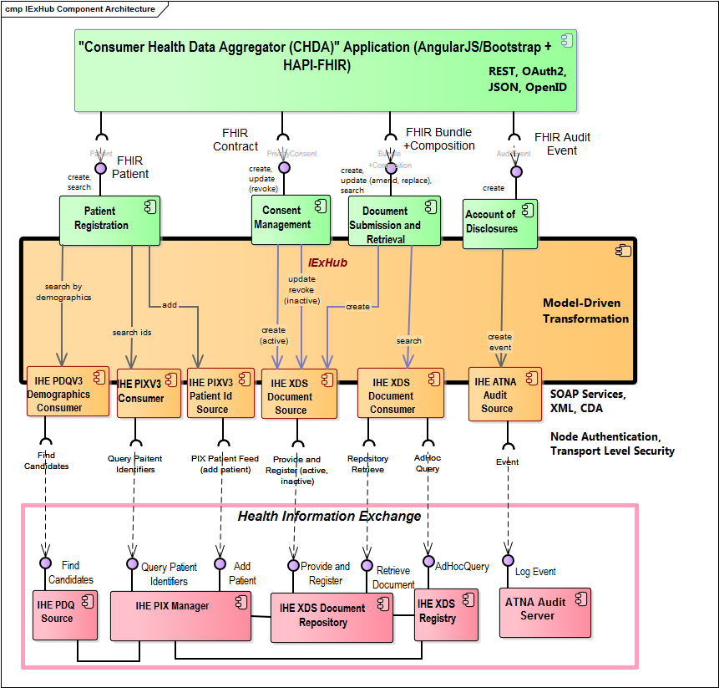

**Figure 2: FHIR-based Hub enables consumer application to access HIE aggregate information**

The consumer-facing application can access the information aggregated by a Health Information Exchange using the IExHub to enable interoperability or directly from an EHR system that supports secure FHIR-based queries based on the consumer’s consent.

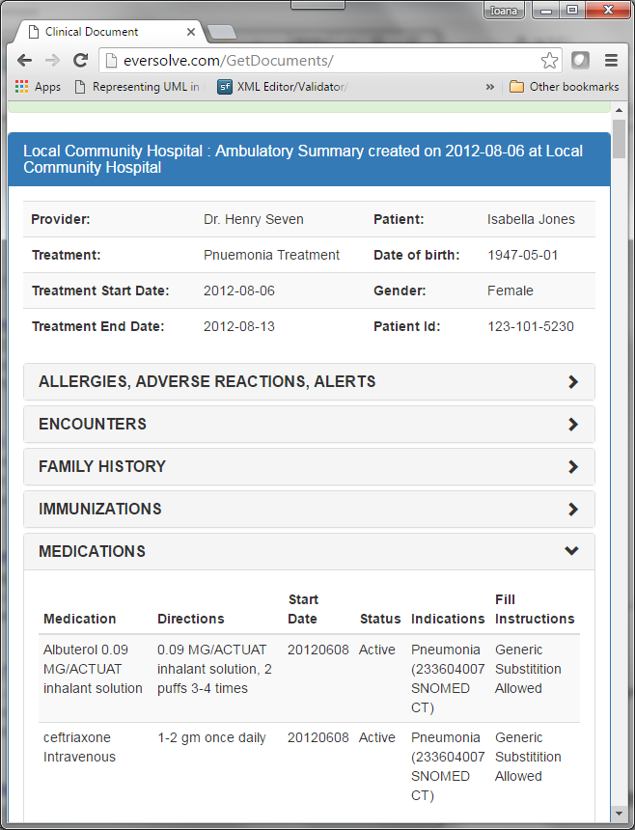

**Figure 3: Mockup mobile application displaying a FHIR-based summary to a consumer/patient**

Figure 3 illustrates how a FHIR-based application can access aggregate information transformed from a C-CDA document intended to support transition of care and summarize the patient’s health information. This type of AngularJS user interface could be displayed on any device from a smart phone, a tablet, to a desktop. The user interface may take advantage of HAPI FHIR [7] and “SMART on FHIR” [11] libraries and security specifications.

The FHIR Bundle and contained FHIR Composition resources are used ot represent a transition-of-care C-CDA document in FHIR for display to consumer. The Argonaut Project spearheaded by leading EHR vendors is creating FHIR profiles to support such transformations as long the transformation technology is available. As discussed in this paper the solution we outline relies on semantic-interoperability enabled by design tools (e.g. CAM editor [4]) and runtime components (e.g. IExHub [3]).

# Problems in Aggregating Health Information

Healthcare interoperability requires information to be semantically precise to ensure that its meaning is interpreted in the same way by both the sending and receiving systems. The challenge posed by semantic consistency increases exponentially when information is exchanged across multiple senders and receivers (many-to-many) across a nationwide network. It is also a pre-requisite for successfully aggregating information from a variety of sources and sharing it using FHIR resources.

In the US, the current state of the health care delivery system is fragmented with many poorly implemented health IT systems still lagging in data (semantic) interoperability despite the billions of dollars spent to certify electronic health record (EHR) systems and launching health information exchange (HIE) solutions to integrate community-based providers.

The current standard implementations have not matured sufficiently to remove ambiguity from the exchange standards or ensure consistent semantics across communities. There are no mandatory implementation standards for HIE organizations even though EHR vendors are converging on a set of Meaningful Use mandated specifications. However the issue of inconsistency is critical for HIEs which are key entities that facilitate electronic health information exchange between providers. Simply validating the structure of a document or message does not ensure the information contained will either be sufficient or be interpreted in the same way for decision support and treatment. The current state of interoperability allows different systems to process and interpret information differently even though the underlying standard structure is valid and includes all the relevant business data elements.

Achieving interoperability across the continuum of care and aggregating information into consistent clinical views requires that all systems must have a common understanding of the information shared regardless of the payload structure or transport. To bridge the differences among systems, a common, standards-based canonical definition of information meaning can help translate from one format to another while maintaining semantic precision. The goal is to allow EHRs and Health Information Exchanges (HIEs) to share information using standard structures (i.e. messages, documents, resources) and terminology as well as leverage standards-based knowledge models using standard terminology systems.

This paper describes how FHIR resources and FHIR-based implementation guides (i.e. Data Access Framework [6]) could be used to access aggregate data sources that reuse data sets exchange using existing standard-based interfaces implemented by EHR systems and HIEs.

## Why Mapping Standards Structure to Aggregate Clinical Data Fails

Throughout this paper, we emphasize the importance of semantic mapping and the use of profiles to constrain standards for precise implementation and transformation. Past attempts to map HL7 Version 2.x message elements to HL7 Version 3 classes have shown the futility of a map that relates an ambiguous concept (e.g., Observation class in V3 to an OBX segment in V2). In most cases, the structure can be constrained into a profile to exchange a certain type of information (e.g., V3 Observation to CDA Problem or V2 OBX to a device-reported blood-pressure measurement). Clearly, attempting to map an unconstrained standard structure to another unconstrained standard structure is not useful or reusable. Semantic mappings, in contrast, are reusable. They document how business data elements are represented in a structure, for example, how a vital sign is represented in either V2 or V3—the same content but in two syntactical representations.

Semantic mapping also requires semantic clarity. Through semantic mapping we can distinguish between the dates (1) when a problem was recorded, (2) was observed, or (3) the year or age when a problem or symptom started. While dates appear trivial, certain qualifiers can clarify the meaning of a business data element and facilitate the creation of profiles and maps. Similarly semantic mapping includes mapping coded data by identifying equivalent concepts and relating local codes to standards (e.g., SNOMED CT, ICD-10, LOINC, RxNorm, etc.).

There are additional factors that affect mapping one healthcare format to another. Using the earlier example, there can be many problems observed by a healthcare professional for a patient. In each observation, data elements for the date, the type of specific problem, the severity of the problem, and who authored the observation are all recorded data elements. For this information to be used correctly later, all of the specific data elements for the observation must be bound together. Therefore, the semantics of a format are not simply represented by the semantics of a specific data element, but rather the semantic clarity of the data element is influenced by how the data elements are organized or structured (i.e., hierarchy). There are additional factors that can have an impact on semantic mapping such as relationships and values of other data elements and these must be understood to achieve a precise meaning and precise structure.

The use of a model-based mapping helps avoid the pitfalls of syntax-based mapping, driving interoperability towards semantic consistency across systems and applications.

FHIR-based queries can be effective if the meaning of the information is consistent between the users/system that make the request for information and the systems that return information to clinicians. The meaning of that information is constrained by a FHIR Profile represented using a “SemanticDefinition” resource and organized into an implementation guide of related resources using such as FHIR DAF implementation guide[6].

# Semantic Consistency across the Continuum of Care

The proposed semantic mapping approach is intended to add semantic consistency across systems using widely-adopted model-driven architecture principles, similar to the HL7 Services-Aware Enterprise Architecture Framework (SAIF). It adds the *semantic versus syntax* model separation introduced by the OASIS Content Assembly Mechanism Version 1.1 (CAM) [2] specification as a technical approach to aggregating data based on well-defined templates that ensure semantic interoperability in many-to-many information exchanges. To address the complexity of healthcare information exchange, the canonical data elements are described using the ISO 11179 metadata registry (MDR) [6]. The canonical data are then reused to establish semantic equivalence across systems, across syntactic models (e.g. HL7 V2, CDA, FHIR, etc.), across knowledge models (e.g. Detailed Clinical Models, CIMI clinical models, OpenEHR clinical models/archetypes) and even across diverse clinical coding systems (e.g., SNOMED CT vs ICD, local system to standard systems). The maps rely on a common “model of meaning”, which is a logical representation of payloads that consist of data elements organized into a well-defined registry or “Business Data Elements Dictionary”. Similar to other standards products, the Business Data Elements Dictionary would derive its authority from a consensus-based change management process organized by a SDO.

Using this approach, each side of the exchange must first map its own data to a business data element (i.e., vital sign result) based on a template. A second map ensures that the standard syntactical structure (e.g. FHIR Observation, HL7 V2 OBX segment, CDA Observation) is used consistently to represent its data element (i.e. Vital Sign Result) in as a standard structure (e.g. FHIR Observation conforming to [DAF-VitalSigns](http://hl7-fhir.github.io/daf/observation-daf-vitalsigns.html) profile) . This approach may map not only across standard-based syntactic models (e.g., CDA, V3, V3, and FHIR), but also across models of clinical knowledge and requirements such as Detailed Clinical Models, Open EHR Archetypes, and the Clinical Information Modeling Initiative (CIMI) that enable Decision Support and analytical processing, research, and patient-centered outcomes analysis.

The software architecture required bringing these concepts to life, ensuring that semantic mapping provided a clear separation between data semantics and syntax/representation. This promotes the development of reusable maps for well-defined implementation specifications. The success of semantic mapping relies on a community of interest and an SDO that can maintain the data elements which make up the Business Data Elements Dictionary.

The architecture must also provide a means of executing semantic maps at runtime and requires a sustaining effort to develop a reusable registry of data elements. SAMHSA has created the Information Exchange Hub (IExHub) project to build the transformation/interface engine supporting both behavioral health and physical health interoperability for HIEs. Our approach includes the reuse of the IExHub to deploy a runtime aggregation solution for health information accessible using FHIR Draft Standard for Trial Use 2 (DSTU2) [1] or Standard for Trial Use 3 (STU3) due for approval in September 2016 [3]

# Benefits of Runtime Model-Driven Interoperability

Previous standards-based mapping projects aimed to facilitate transition from one standard and syntax to another (e.g., HL7 Version 2 ASCII Encoded messages mapped to HL7 Version 3 XML messages). These projects attempted to map the entire standard to its newer version without considering that both versions required additional refinements and constraints for real-world implementations.

Due to the unconstrained definitions or specified optionality of the base standards, mapping an entire standard from one format to another has proven to be unreliable. In programmatic terms, the mapping of one base class to another base class while ignoring that each class must be further specialized prior to instantiation cannot guarantee semantic interoperability. This mapping approach fails to align semantically equivalent data elements because the interoperability standards contain generic concepts and optionality intended for adaptability to a multitude of implementations. Therefore, mapping of base standards is inherently imprecise, requiring instead a semantics-driven solution.

The proposed solution includes model-driven semantic maps that are directly executable by the IExHub runtime environment which supports the bi-directional exchange of business data and information independent of format:

* CDA R2 (using C-CDA templates)
* FHIR (resources/profiles)
* HL7 Version 2 (use case specific implementation guides)
* Other formats as identified (X12, NCPDP)

Additionally, the IExHub provides a number of connectors for specific transport protocol and envelope formats to support the exchange of standard-encoded messages and documents:

* REST
* SOAP (IHE ITI Integration Profiles, NwHIN Connect/eHealth Exchange)
* S/MIME (NwHIN Direct)
* HL7 Minimal Lower Layer Protocol (MLLP)

# S**emantic Mapping Design**

Semantic maps are created using an open-source that is the de-facto business analyst’s “workbench” (i.e. MDI Workbench). It integrates existing open-source CAM templated editor to put subject matter experts in charge of defining maps and creating model-based implementation guides for information exchange standards.

The workbench combines standards profiling and semantic mapping thus leveraging the work into a single definition that can be leveraged not only for FHIR resource aggregation but also other standards.

The CAM editor allows an analyst to create or edit maps that relate local EHR/HIE source data to information exchange formats using the Business Data Elements Dictionary. The map editor could also be applied to creating “standard” maps that specify how a canonical data element is represented in FHIR (i.e. a FHIR-specific map that may be reused across related project). This leads to standards-based implementation guides which satisfy, in a verifiable way, a need for semantic information sharing. The logical payload supported by an implementation guide consists of data elements defined in the Business Data Elements Dictionary and provides implementers with the detailed knowledge to represent that logical payload in a standard-based syntactic structure (e.g. CDA document, V2 message, FHIR transaction) and terminology (e.g. LOINC value sets).

Figure 2 describes how using a template-driven semantic mapping based on common set of business elements. This approach can be extended and invoked to translate the EHR data to a variety of formats, for example, from C-CDA 1.1 to FHIR and HL7 Version 2.x implementation guides. To enable the adoption of standards, the Business Data Elements Dictionary should be developed by the SDO to specify data elements semantically within an implementation guide. Interested stakeholders can reuse the maps at design-time and generate run-time specifications consistent with model-driven architecture principles.

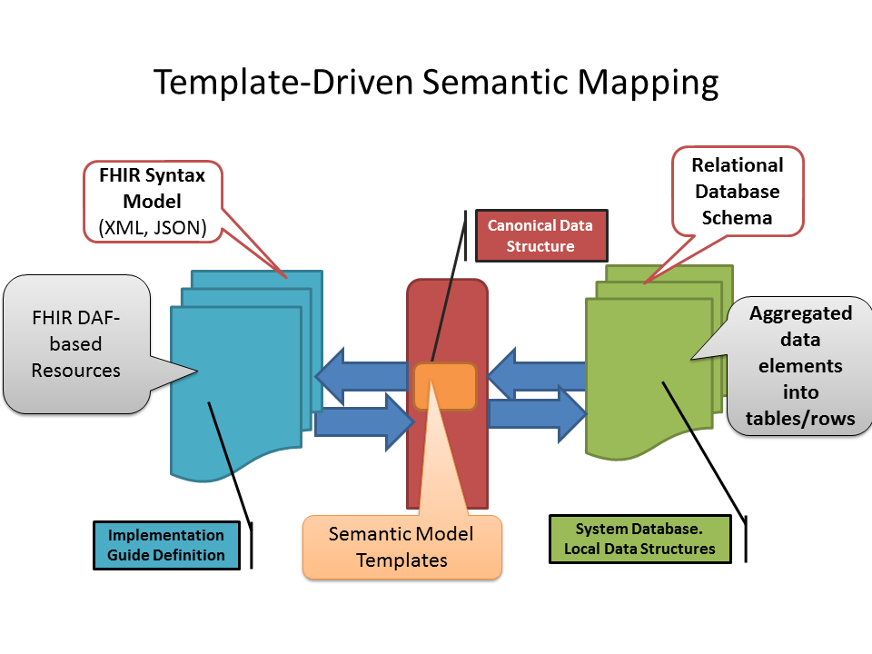

**Figure 4: Template-driven Data Aggregation using Semantic Mapping**

At runtime, the map configured for specific endpoints is executed by dedicated software components.. Thus mapped, the EHR local data can then be represented correctly as an implementation guide-specific payload. A standard set of maps, which will be provided in the open source project, would describe how business data is represented in a specific CDA template, HL7 Version 2 profile, or FHIR profile (i.e., logical data exchange). As new implementation guides and profiles/templates are developed, the Business Elements could be referenced alongside each constraint applied to the standard.

A model-driven approach promotes the reuse of the Business Data Elements Dictionary as the canonical representation of all the data exchanged through any interoperability specifications. The importance of semantic business data when creating a new profile or template is evident in the way other open-source tools such as CAM Editor[4] begin the development of a new template by first creating a data model of required data and then applying the necessary constraints to the underlying standard structure to support the data set. The model-driven approach promotes the reuse of business data elements by:

* Helping applications clarify the semantics of their local data
* Helping profile developers clarify how a message or document would represent the Business Elements in an interoperable way, using standard constructs and syntax

The Business Data Elements Dictionary may use a rigorous post-coordinated expression that combines the meaning of well-defined standard concepts (e.g. Allergy + observation + date/time). These computable expressions can be used to de-duplicate and navigate the Business Data Elements Dictionary for precise mapping and transformation to create consistent FHIR objects across a variety systems.

# MDI Runtime Transformations

Semantic maps allow information systems to specify how their local format/syntax relates to the canonical data elements in Business Data Elements Dictionary. To transform data between two syntactic models, a second map is required to specify how the canonical data elements are represented to a target representation. To facilitate reuse each implementation guide may have an associated map that represents the community consensus on how a specific data item (e.g. vital sign result) is represented in a standard syntax (e.g. the Observation value data element of the C-CDA template). This ensures that EHR systems can exchange health information in a manner that guarantees that the content of the information is understood across disparate systems, thereby allowing for semantic interoperability.

A **transformation** consists of two mapping operations: first from a source structure to a canonical data definition and a second from the canonical data definition to the target syntax specified by an implementation guide. The IExHub automatically executes the necessary map sequence based on the source and target format and implementation guides invoked at runtime.

MDI transformations allow EHR systems to (1) migrate selected interfaces to later versions of the standards, (2) adopt new information exchange formats such as FHIR, and (3) maintain backward compatibility with existing interfaces inside and outside the enterprise. The transformations also allow the systems to support more than one exchange syntax/format for a logical payload.

In addition to executing semantic maps, the IExHub can also act as an application gateway linking FHIR-based applications with existing SOAP-based HIEs. The IExHub can map not only data but system capabilities and behavior (e.g., the application invokes FHIR Patient “search” to transmit the IHE ITI-47 PDQV3 Query message supported by the HIE). The transformation includes mapping payloads and transport from FHIR over REST to HL7 V3 with ebXML over SOAP.

## Transforming Atomic and Aggregate Data

Most of the transactions and message exchanges currently implemented using standards share three characteristics. They aggregate information corresponding to a specific focal structure:

* Messages (e.g. HL7 Version 2, X12, and NCPDP)
* Documents (e.g. CDA documents, FHIR resource, HQMF, and QRDA)
* Support simple interaction modes:
  + Unsolicited notifications (e.g. laboratory results reports)
  + Request/Response transaction (e.g. order request message/order response message)
  + HL7 FHIR adds support for atomic data objects

FHIR and CDA will coexist for the near future as they address complementary requirements.

* FHIR supports access to atomic elements while CDA provides access to aggregate objects containing both narrative text and structure.
* FHIR supports queries for discrete data elements while CDA supports only queries for documents or document sets.

Thus, CDA is ideal for large transactions containing a variety of sections and objects. In contrast, FHIR provide access to specific data elements (e.g. lab results, patient records, and provider records).

A mapping-based approach using CAM allows the FHIR, CDA other required interoperability standards to co-exist and fulfill the requirements of various projects. An HIE or another system can persist information received using a variety of format and persist it.

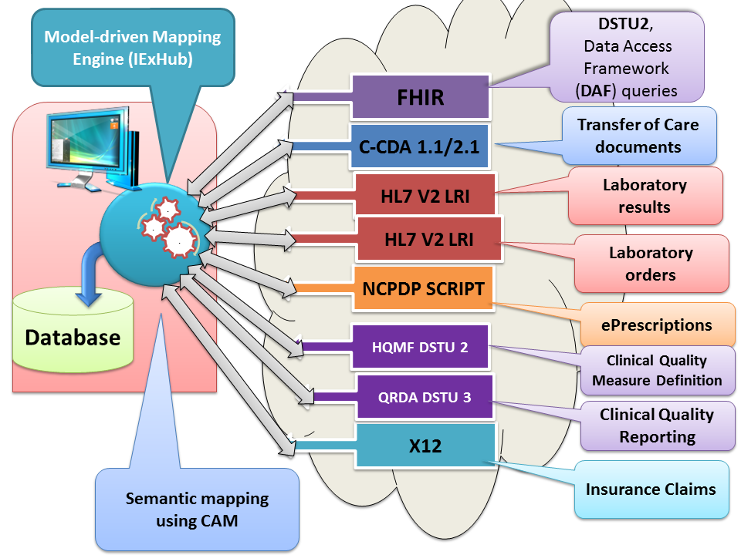

**Figure 5: Standards format/syntax transaction persisted by an aggregate database**

FHIR allows other systems to access specific, granular resources to be queries. Rather than retrieving one or more CDA documents, the client EHR system could access only specific types of information (e.g. laboratory results) The HIE would have already aggregated laboratory results from C-CDA or HL7 Version 2 LRI transaction. Document retrieval provides less flexibility and it creates more overhead than targeted queries for a specific types of information accessible through a set of standard-based RESTful services and enabled by semantically mapping the contents of the aggregate HIE database to the desired FHIR resource specific by a US-constrained profile (e.g.DAF-Results profile part of the DAF IG. [6]).

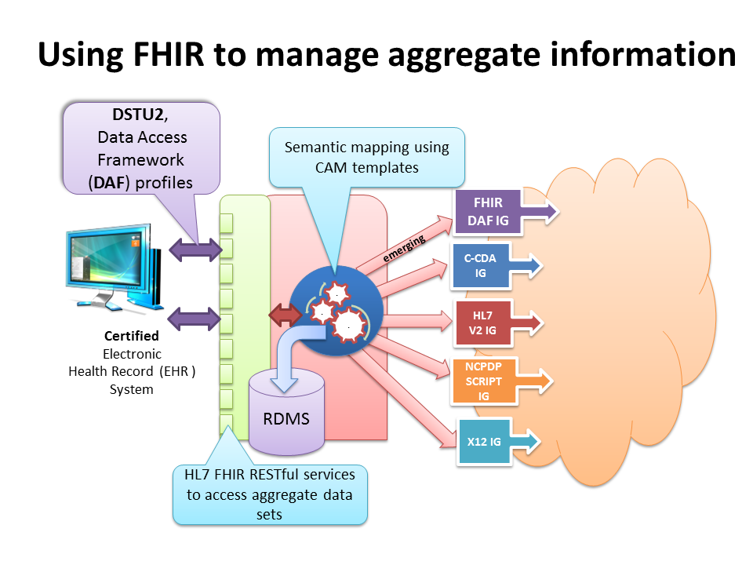

**Figure 6: Retrieving Granular/Atomic Data from Aggregate HIE Database**

Not only is the document information mapped from one format to another, it is done with complete semantic integrity because the Business Data Elements Dictionary data element represents the conical definition used by each template definition. Now we begin to see synergy between the different standard formats and convergence across the various areas of the health continuum for where the different formats provide the most value.

A model-based, semantic mapping approach separates content from syntax to allow the exchange of business data consistently across systems. Whether using FHIR, CDA, or HL7 V2, an EHR system is able send or process laboratory results. The laboratory result data content is the same. To illustrate the contents of the data following is a mock-up clinical application inspired by industry best-practices (i.e. Veteran’s Health Administration Computerized Patient Record System CPRS) in addition to simple “mobile device” view of aggregate information in Figure 3.

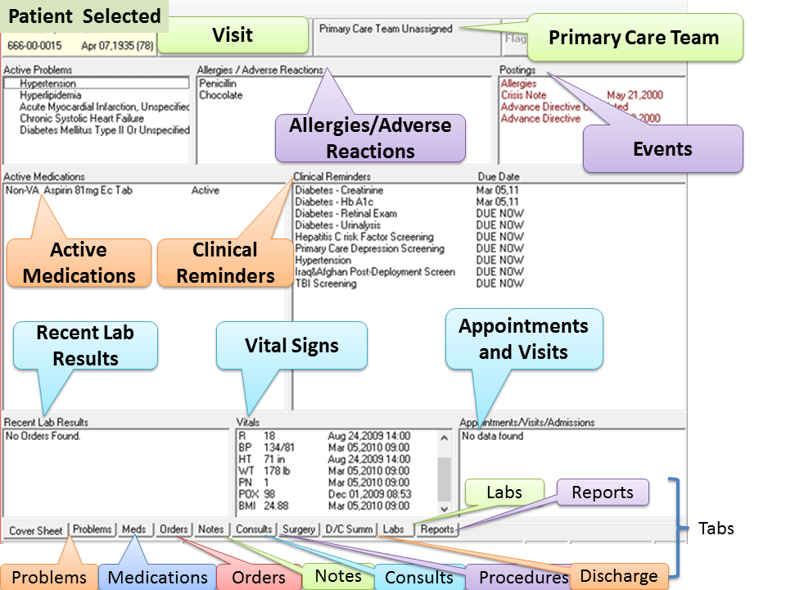

**Figure 7: Clinical Information System to display aggregate data sets**

The aggregated FHIR data set can be used to populate the user interface with the contents of FHIR resources that conform to a specific set of profile specified in DAF[6].

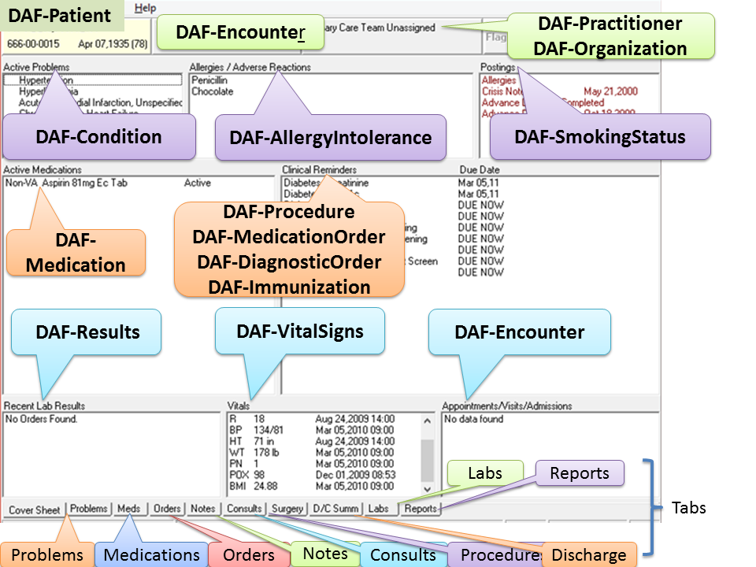

**Figure 8: FHIR resources displayed by an system operating on aggregate data sets**

Figure 6 illustrates the panels and tabs that are used to create a summary “cover sheet” of relevant, recent information selected from an aggregate information. Each tab provides the detailed information on a specific type of data.

For an implementer, the difficulty increases each time a new implementation guide or format is proposed for adoption. Each system must map local business data to a variety of formats (e.g. HL7 Version 2, CDA R2, and FHIR) based on the constraints and criteria defined by implementation guides (e.g. C-CDA, Laboratory Results Interface, and Health Quality Measure Format). The challenge for implementers is not only to understand the information exchange format, the implementation constraints, and implementation guidance, but also to create semantic relationships between local data elements and the standard data element identified in the target implementation guide. If these semantic relationships are incorrect, the resulting CDA document or HL7 Version 2 message may pass validation and even certification but may carry the incorrect business data. These semantic errors may amplify when an HIE or another data aggregation system combines information received from multiple senders. Each semantic error further limits the ability of such systems to process the data pertaining to a patient of population.

# Conclusions

The inherent complexities in adopting multiple information exchange syntax models and terminologies in interoperability scenarios are mitigated using a CAM-based implementation approach and it also allows any EHR system that is a “certified Health IT product” to provide aggregate information for consumer-facing application. The principles and architecture outlined in this paper encourage a community of interest to contribute template-based maps and enable aggregate repositories that expose information using uniform set of FHIR-based resource. Aggregating clinical data using FHIR must also address a variety of interoperability specifications and leverage clinician-designed knowledge and create a framework to support these standards in a semantically-interoperable framework bridging the provider-to-consumer interoperability..

Key benefits of semantic-interoperability and aggregation include:

* Simplifying the process of mapping local system or other local data to standard semantic definitions using a canonical information representation, ensuring that information semantics rather than format drive any decision related to mapping data across systems and organizations.
  + This simplification allows for a gradual and seamless transition to FHIR and discrete data elements rather than text-based documents.
* Create reusable open-source mapping definitions that enable diverse EHR or other systems to conform to common information exchange formats. A library of mapping/transformation models specific to an information exchange standard implementation guide (e.g. FHIR DAF, HL7 C-CDA 1.1, HL7 LRI, etc.) would ensure that meaning of business information is mapped identically across information exchanges.
* Promote a rigorous adoption to implementation guides rather than ambiguous standard exchange format. This is an important principle that acknowledges that health information technology standards require explanation using additional constraints before a real-life implementation is possible. Therefore, by mapping to an implementation guide or a profile of a standard, we ensure that the business semantics are clearly addressed and have unambiguous or unique representations in the payload for each business data element. This principle also guarantees that the complexity of the “on the wire” representation of business data is isolated to a specific map and does not permeate into an application’s own representation, thus separating concerns of application optimization from information exchange optimization.
* Promote model-based development of specifications for new profiles and templates traceable to the well-defined, consensus based business data dictionary leading to an implementation ready specification.

# References

**[1]** HL7 Fast Healthcare Interoperability Resources (FHIR) Draft Standard for Trial Use 2 (DSTU2)

<https://www.hl7.org/fhir/DSTU2/>

**[2]** OASIS Content Assembly Mechanism (CAM) Version 1.1  
 <http://docs.oasis-open.org/cam/>

**[3]** HL7 Community-Based Collaborative Care Project Site on Information Exchange Hub (IExHub):   
[gforge.hl7.org/gf/project/cbcc/frs/IExHub_Interop_Projects](http://gforge.hl7.org/gf/project/cbcc/frs/IExHub_Interop_Projects)

**[4]** CAM Reference Implementation “CAM XML Editor for XML+JSON+Hibernate+SQL Open-XDX sponsored by Oracle”  
<https://sourceforge.net/projects/camprocessor>

**[5]** MDR ISO /IEC 11179 Metadata Registry (MDR) standard

[6] FHIR Data Access Framework (DAF) Implementation Guide  
 (<http://hl7-fhir.github.io/daf/daf.html> )

[7] HL7 API (HAPI) FHIR Java Implementation

<http://hapifhir.io/download.html>

<https://github.com/jamesagnew/hapi-fhir>

[8] ONC Health IT Certification Product – Certified Health IT Product List  
<https://www.healthit.gov/policy-researchers-implementers/certified-health-it-product-list-chpl>

[9] HEART Work Group

<http://openid.net/wg/heart/>

[10] BHIT Project FHIR Consent Profile Release:   
<http://gforge.hl7.org/gf/project/cbcc/frs/?action=FrsReleaseBrowse&frs_package_id=303>

[11] SMART on FHIR project: http://docs.smarthealthit.org/

[12] Argonaut Project: http://argonautwiki.hl7.org/index.php?title=Main_Page